
DEPARTMENT OF

COMPUTER

Experiment 7
Student Name:Riya Kashyap UID: 25MCA20033
Branch: MCA-UIC Section/Group: 1
Semester: 2nd Date of Performance:31/03/2026
Subject Name: Technical Training Subject Code: 25CAP-652

- Aim:To implement and analyze different types of SQL joins in PostgreSQL including INNER JOIN, LEFT JOIN, RIGHT JOIN, SELF JOIN, FULL JOIN, and CROSS JOIN.
- Objective:To understand and apply various join operations on a relational database schema consisting of Students, Courses, Enrollments, and Departments tables to extract meaningful information.
- Tools Used:
- PostgreSQL
- pgAdmin (for query execution)
- Theory
In relational databases, data is often stored in multiple tables to maintain normalization. SQL joins are used to combine these tables based on related columns.
Different types of joins include:
- INNER JOIN: Returns only matching records from both tables.
- LEFT JOIN: Returns all records from the left table and matched records from the right table; otherwise NULL.
- RIGHT JOIN: Returns all records from the right table and matched records from the left table; otherwise NULL.
- FULL JOIN: Combines results of both LEFT and RIGHT joins, showing all records with NULLs where no match exists.
- CROSS JOIN: Produces all possible combinations (Cartesian product) of rows.
- SELF JOIN: A table joined with itself to compare rows within the same table.
These joins help in efficient querying, minimizing redundancy, and extracting related data.

Practical / Experiment Steps

Step 0: Table Creation

CREATE TABLE students (
student_id INT PRIMARY KEY,
student_name VARCHAR(50),
dept_id INT
);
CREATE TABLE courses (
course_id INT PRIMARY KEY,
course_title VARCHAR(50)
);
CREATE TABLE enrollments (
student_id INT,
course_id INT,
PRIMARY KEY (student_id, course_id)
);
CREATE TABLE departments (
dept_id INT PRIMARY KEY,
dept_name VARCHAR(50)
);

Step 1: Insert Sample Data

-- Students
INSERT INTO students VALUES
(101, 'Aman', 1),
(102, 'Riya', 2),
(103, 'Rahul', 3),
(104, 'Sneha', 4),
(105, 'Arjun', 1);
-- Courses
INSERT INTO courses VALUES
(201, 'Database Systems'),
(202, 'Cloud Computing'),
(203, 'Artificial Intelligence'),
(204, 'Computer Networks');
-- Enrollments
INSERT INTO enrollments VALUES
(101, 201),
(101, 202),
(102, 203),
(103, 201),
(104, 204);
-- Departments
INSERT INTO departments VALUES
(1, 'Oracle'),
(2, 'SAP'),
(3, 'IBM'),
(4, 'Microsoft');

Step 2: INNER JOIN

SELECT s.student_id, s.student_name, c.course_title
FROM students s
INNER JOIN enrollments e ON s.student_id = e.student_id
INNER JOIN courses c ON e.course_id = c.course_id;
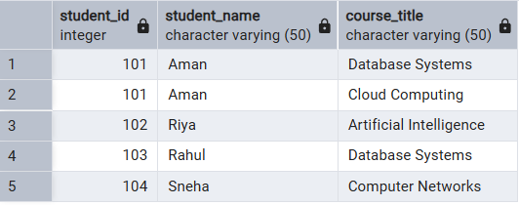

Step 3: LEFT JOIN

SELECT s.student_id, s.student_name
FROM students s
LEFT JOIN enrollments e ON s.student_id = e.student_id
WHERE e.student_id IS NULL;
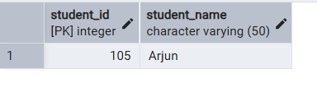

Step 4: RIGHT JOIN

SELECT s.student_name, c.course_title
FROM enrollments e
RIGHT JOIN courses c ON e.course_id = c.course_id
LEFT JOIN students s ON e.student_id = s.student_id;
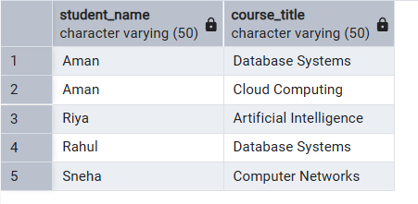

Step 5: Join wth departments

SELECT s.student_id, s.student_name, d.dept_name
FROM students s
JOIN departments d ON s.dept_id = d.dept_id;
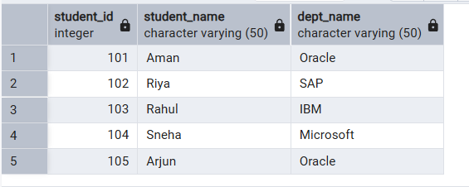

Step 6: CROSS JOIN

SELECT s.student_name, c.course_title
FROM students s
CROSS JOIN courses c;
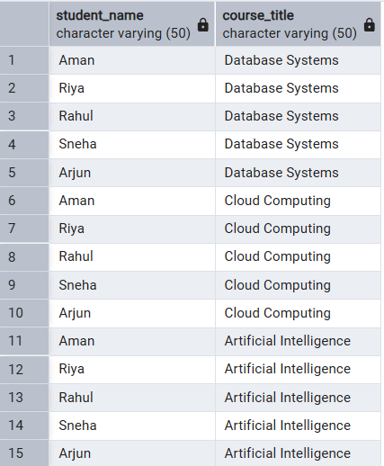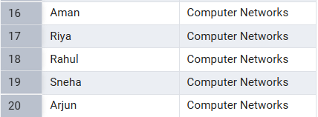

Step 7: FULL JOIN

SELECT s.student_name, c.course_title
FROM students s
FULL JOIN enrollments e ON s.student_id = e.student_id
FULL JOIN courses c ON e.course_id = c.course_id;
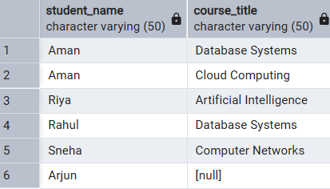

- Learning Outcome:
- Gained practical understanding of SQL joins and their real-world applications.
- Learned to retrieve and combine data from multiple related tables.
- Understood differences between INNER, LEFT, RIGHT, FULL, and CROSS joins.
- Developed ability to write efficient queries for data analysis.
- Improved hands-on experience with PostgreSQL.

